Appendix - I
Source Code
Github repo:
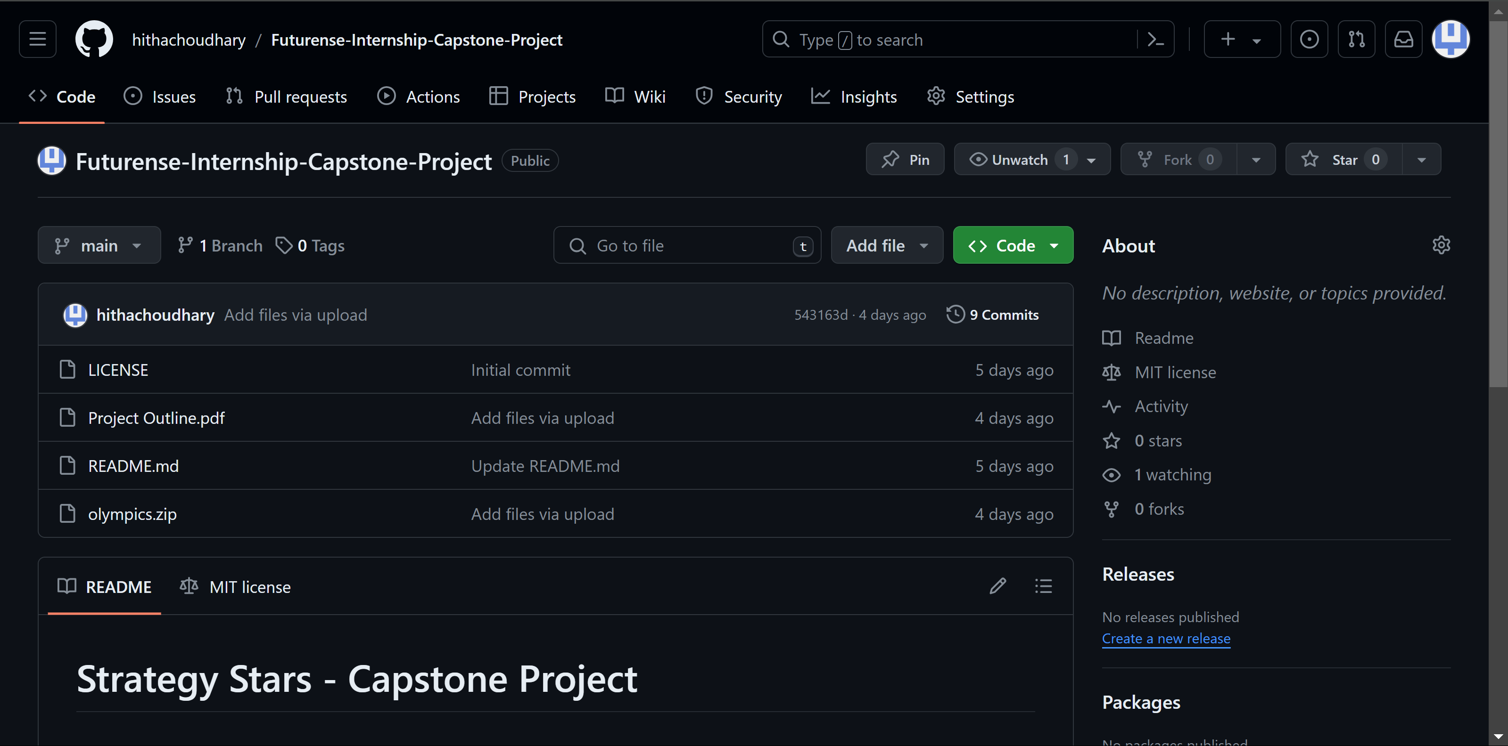

Github Link: https://github.com/hithachoudhary/Futurense-Internship-Capstone-Project

Source Code Snippet:
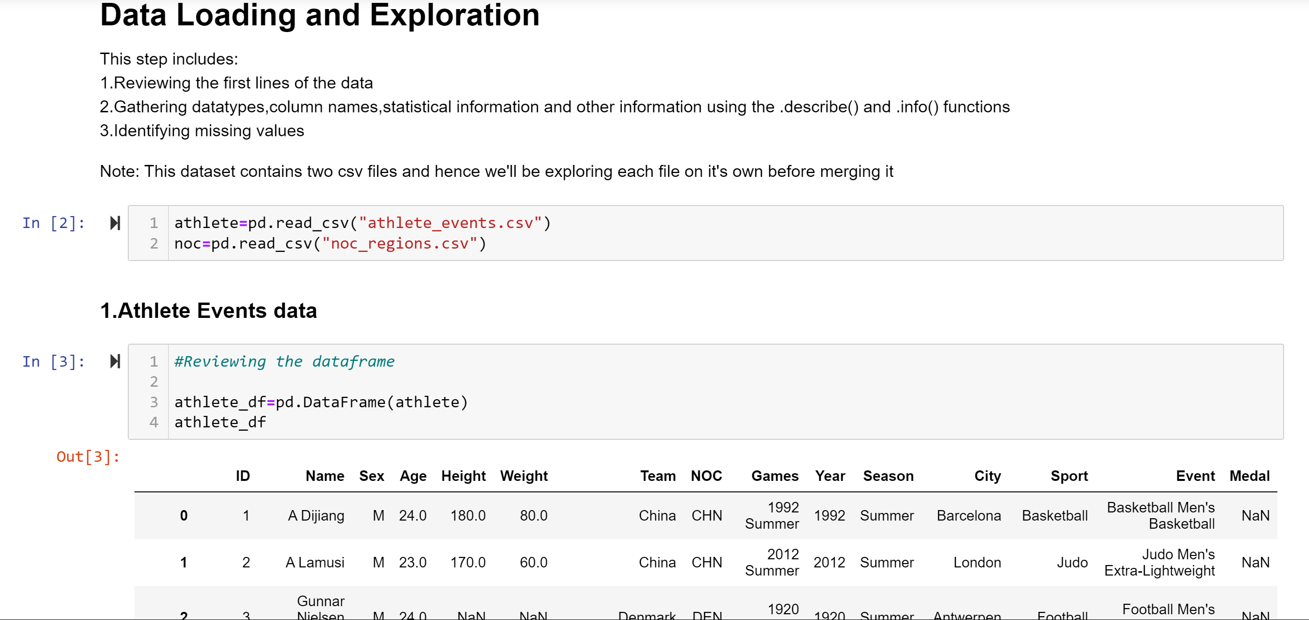
Appendix-II
Datasheets

“The Olympics” dataset consists of two csv files:
athletes.csv:
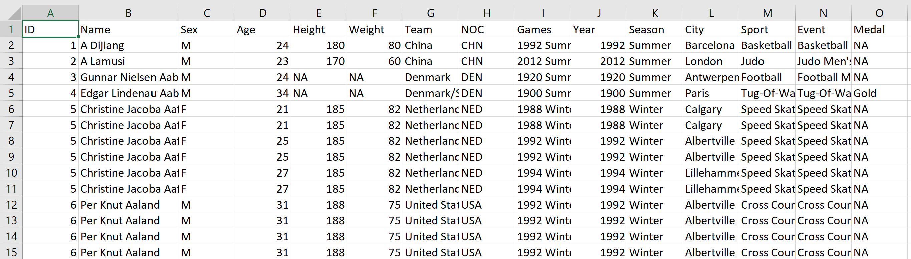
this dataset consists of a total of 271116 rows and 17 columns

noc_regions.csv
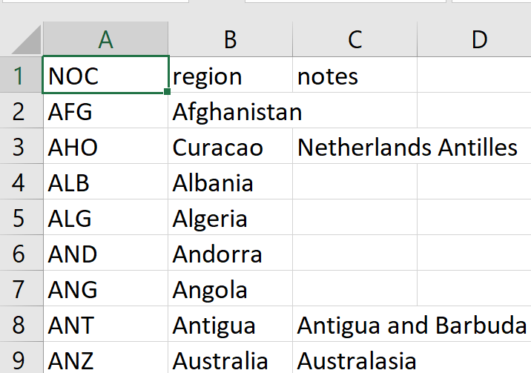
This dataset consists of a total of 230 rows and 3 columns

